FY2021 EVENT  FOLLOW-UP  REPORT | 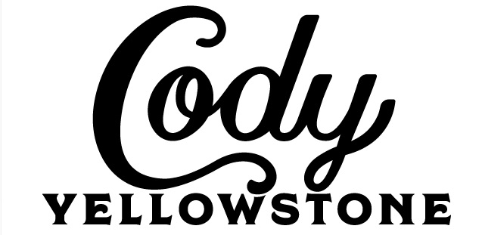 | PARK COUNTY  TRAVEL  COUNCIL

1. Name of Event ____________________________________________________________________

2. Organization ______________________________________________________________________

3. Date of Event _________________________How many years has this event taken place?_______

4. Amount Granted by PCTC: $_________________

5. Were funds received from other sources for this event? If “yes”, list sources: ___________________

___________________________________________________________________________________

6. What advertising for your event was most effective? _______________________________________

Why ____________________________________________________________________________

7. Least effective? ________________________________Why _______________________________

8. How many participants were expected to participate in this event? ___________________________

9. How many participants actually participated? ____________________________________________

10. How many spectators were expected to attend this event? _________________________________

11. How many spectators actually attended? _______________________________________________

12. What percentage was out-of-state? ___% Spectators ___% Participants

13. What percentage was out-of-Park County? ___% Spectators ___% Participants

14. In what ways can this event improve? _________________________________________________

15. Please rate how your event affected business for the following:
(4 = High impact, 3 = Medium impact, 2 = Low impact, 1 = No impact)

___ Hotels/Motels ____ Restaurants ____ Retailers ____ Attractions ___ Airport

Other _____________________________ Explain _______________________________________

16. Please summarize the highlights of this years’ event: ______________________________________

___________________________________________________________________________________

Please attach a financial summary of this event (income and expenses).

PARK COUNTY TRAVEL COUNCIL
P.O. Box 2454 – Cody, WY 82414 – (307) 586-1574 – www.CodyYellowstone.org

