|  |  |  |
| --- | --- | --- |
| **FY2022 EVENT**  **SPONSORSHIP**  **REQUEST** | Cody-Logo-Black | **PARK COUNTY**  **TRAVEL COUNCIL**  Date Received: |

1. Name of Event ____________________________________________________________________

2. Organizing Entity __________________________________________________________________

3. Address _________________________________________________E-mail___________________

4. Contact Person(s) ______________________________________________Phone______________

5. Date(s) of Event ________________________________Location: Meeteetse Cody Powell Other

6. Location/Facility which will be used:____________________________________________________

___________________________________________________________________________________

7. Will this event take place if the PCTC does not assist with funding? ___________

8. Amount Requested from PCTC: $____________ Sponsorship award can only be used for promotion.

9. Number of anticipated attendees: __________

10. Entry/Admission Fee: $ ___________

11. List other funding sources __________________________________________________________

12. Is this the first year your organization has hosted this event? ________________________________

13. **Please provide a one page description of the event, its history and advertising media schedule.**

*Accuracy in completing this request is essential as this will determine level of PCTC sponsorship*.

*Organizers must complete an* ***Event Follow-up Report*** *within two weeks after the event*.

**Event Sponsorship is given on a reimbursement basis. Request for Payment form must be completed and submitted with paid invoices to receive awarded reimbursement.**

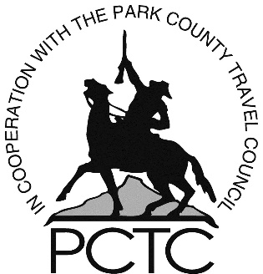

PCTC funding logo should appear on all event promotions.

******************************************************************************************************************************************

Office Use Only:

Amount Awarded $____________________ Date Approved _________________ Check No: __________________

Signature of Recipient of check: ___________________________________________________________________

Printed Name _________________________________________________________________________________

**EXAMPLE**



**Event Sponsorship Guidelines:**

Sponsorship Request applications must be received well in advance of event to allow for adequate advertising or coordination. Sponsorships are considered at each PCTC monthly meeting – the third Thursday of each month. Applications are due at the PCTC office no later than the second Thursday of each month. Sponsorships are awarded on a first come, first served basis.

1. Funds must be used for a special event utilizing a facility or facilities in Park County.
2. Event must be able to bring attendees from outside Park County and preferably spend the night.
3. Event must have a definite starting and ending date (no on-going programs).
4. Consider a “heads on beds” approach to funding. The larger the number of attendees, the higher the sponsorship level.
5. Preference will be given for events held August 15 through June 15.
6. An **Event Follow-Up Form** must be provided to the PCTC office within two weeks of the completion of the event. If one is not filed, the entity will not be considered for future event sponsorship.
7. Recognition should be given to the PCTC as a sponsor:

Hang banner in facility/field if possible

PCTC recognition in program as a sponsor

PCTC recognition on any merchandise (T-shirts, caps, etc.)

PCTC logo on promotional ads and materials

Announce PCTC as sponsor: “Sponsored in part by the Park County Travel Council; promoting Cody/Yellowstone Country as a vacation destination. Visit [www.CodyYellowstone.org](http://www.CodyYellowstone.org) for information.”

The PCTC goal is to assist events allowing them to grow. Our sponsorship assistance is not intended to be ongoing and will likely be reduced each time a Sponsorship Request is considered for the same event.