FY2023 EVENT  FOLLOW-UP  REPORT | 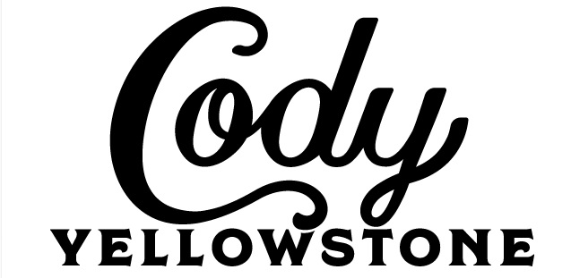 | PARK COUNTY  TRAVEL  COUNCIL

1. Name of Event ____________________________________________________________________

2. Organization ______________________________________________________________________

3. Date of Event _________________________How many years has this event taken place?_______

4. Amount Granted by PCTC: $_________________

5. Were funds received from other sources for this event? If “yes”, list sources: ___________________

___________________________________________________________________________________

6. What advertising for your event was most effective? _______________________________________

Why ____________________________________________________________________________

7. Least effective? ________________________________Why _______________________________

8. How many participants were expected to participate in this event? ___________________________

9. How many participants actually participated? ____________________________________________

10. How many spectators were expected to attend this event? _________________________________

11. How many spectators actually attended? _______________________________________________

12. Estimated number of out-of-state attendees? ___ Spectators ___ Participants

13. Estimated number of out-of-Park County attendees? ___ Spectators ___ Participants

14. In what ways can this event improve? _________________________________________________

15. Please rate how your event affected business for the following:
(4 = High impact, 3 = Medium impact, 2 = Low impact, 1 = No impact)

___ Hotels/Motels ____ Restaurants ____ Retailers ____ Attractions ___ Airport

Other _____________________________ Explain _______________________________________

16. Please summarize the highlights of this years’ event: ______________________________________

___________________________________________________________________________________

Please attach a financial summary of this event (income and expenses).

PARK COUNTY TRAVEL COUNCIL P.O. Box 2454 – Cody, WY 82414 – (307) 586-1574 www.CodyYellowstone.org
Event Sponsorship Guidelines:

Sponsorship Request applications must be received no closer than 30 days prior to the event, although it is highly encouraged that this application is received by PCTC months in advance. This allows for adequate advertising or coordination. Sponsorships are considered at each PCTC monthly meeting – the third Thursday of each month. Applications are due at the PCTC office no later than the second Thursday of each month. Sponsorships are awarded on a first come, first served basis. If the organization is awarded a sponsorship, the organization will receive a check for half of the amount awarded after the monthly board meeting, and the other half will be given within 30 days of receiving the completed follow-up form.

Criteria

- Funds must be used for an event taking place in Park County.
- Event should have the potential to bring attendees from outside Park County and preferably spend the night.
- Typically, a one-day event will receive from PCTC up to $500/day for advertising or facility costs. Exceptions can be made based on the merit of each event. PCTC funds are to be used for event marketing and specific approved event related expenses. Alcohol will not be approved.

Additional consideration will take place if:

- Event is specifically for non-resident attendees
- Enhance quality of life for residents
- Contributes to the betterment of the tourism infrastructure
- Event is held October - May.
- Consider a “heads on beds” approach to funding. The larger the number of non-resident attendees, the higher the sponsorship level.
- Includes multiple funding sources other than PCTC
- An Event Follow-Up Form must be provided to the PCTC office within one month of the completion of the event. If one is not filed, the entity will not be considered for future event sponsorship.
- Best practices of reporting for the Follow-Up Report for the year prior were used
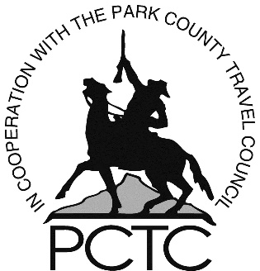
Recognition should be given to the PCTC as a sponsor:
- PCTC funding logo should appear on all event promotional ads and materials.
- Display PCTC’s sponsorship banner at your event. Banner will be picked up and dropped off at 836 Sheridan Ave., Cody, WY, 111 S Day St, Powell, WY 82435 or 1906 State St, Meeteetse, WY 82433
- Please provide picture of PCTC banner(s) displayed at your event.
- Provide your social tags to PCTC prior to your event.
- Tag #codyyellowstone on all social platforms during your event.
- PCTC recognition on any merchandise (T-shirts, caps, etc.)
- Announce PCTC as sponsor: “Sponsored in part by the Park County Travel Council; promoting Cody Yellowstone as a vacation destination. Visit www.CodyYellowstone.org for information.”

Examples of Best Practices of Reporting for the Follow-Up Report
- Follow-Up Report and all material are sent to PCTC within 30 days of the last day of the event
- Follow-Up report is complete
- License plates are counted for an accurate non-resident attendee count
- All social media is show in one document with the use of #codyellowstone
- A picture of the PCTC banner is included
- All traditional marketing material is show in one document with the PCTC logo included

The PCTC goal is to assist events allowing them to grow. Our sponsorship assistance is not intended to be ongoing and will likely be reduced each time a Sponsorship Request is considered for the same event.

Event Contact Signature: _______________________________ Date: ________________

