FY2023 EVENT  SPONSORSHIP  REQUEST | 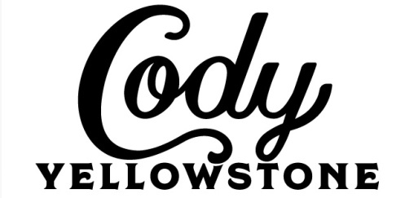 | PARK COUNTY  TRAVEL COUNCIL  Date Received:

1. Name of Event ____________________________________________________________________

2. Organizing Entity __________________________________________________________________

3. Address _________________________________________________E-mail___________________

4. Contact Person(s) ______________________________________________Phone______________

5. Date(s) of Event ________________________________Location: Meeteetse Cody Powell Other

6. Location/Facility which will be used:____________________________________________________

___________________________________________________________________________________

7. Will this event take place if the PCTC does not assist with funding? ___________

8. Amount Requested from PCTC: $____________ Sponsorship award can only be used for promotion.

9. Number of anticipated attendees: __________

10. Entry/Admission Fee: $ ___________

11. List other funding sources __________________________________________________________

12. Is this the first year your organization has hosted this event? ________________________________

13. Please provide a one page description of the event, its history and advertising media schedule.

Accuracy in completing this request is essential as this will determine level of PCTC sponsorship.
Organizers must complete an Event Follow-up Report within two weeks after the event.
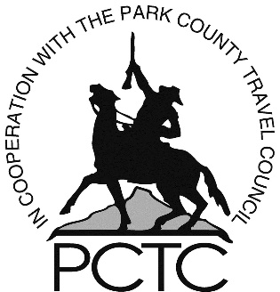
Please review all requirements on page 2, number 7.

******************************************************************************************************************************************
Office Use Only:
Amount Awarded $____________________ Date Approved _________________ Check No: __________________

Signature of Recipient of check: ___________________________________________________________________

Printed Name _________________________________________________________________________________

Event Sponsorship Guidelines:

Sponsorship Request applications must be received no closer than 30 days prior to the event, although it is highly encouraged that this application is received by PCTC months in advance. This allows for adequate advertising or coordination. Sponsorships are considered at each PCTC monthly meeting – the third Thursday of each month. Applications are due at the PCTC office no later than the second Thursday of each month. Sponsorships are awarded on a first come, first served basis. If the organization is awarded a sponsorship, the organization will receive a check for half of the amount awarded after the monthly board meeting, and the other half will be given within 30 days of receiving the completed follow-up form.

Criteria

- Funds must be used for an event taking place in Park County.
- Event should have the potential to bring attendees from outside Park County and preferably spend the night.
- Typically, a one-day event will receive from PCTC up to $500/day for advertising or facility costs. Exceptions can be made based on the merit of each event. PCTC funds are to be used for event marketing and specific approved event related expenses. Alcohol will not be approved.

Additional consideration will take place if:

- Event is specifically for non-resident attendees
- Enhance quality of life for residents
- Contributes to the betterment of the tourism infrastructure
- Event is held October - May.
- Consider a “heads on beds” approach to funding. The larger the number of non-resident attendees, the higher the sponsorship level.
- Includes multiple funding sources other than PCTC
- An Event Follow-Up Form must be provided to the PCTC office within one month of the completion of the event. If one is not filed, the entity will not be considered for future event sponsorship.
- Best practices of reporting for the Follow-Up Report for the year prior were used
Recognition should be given to the PCTC as a sponsor:
- PCTC funding logo should appear on all event promotional ads and materials.
- Display PCTC’s sponsorship banner at your event. Banner will be picked up and dropped off at 836 Sheridan Ave., Cody, WY, 111 S Day St, Powell, WY 82435 or 1906 State St, Meeteetse, WY 82433
- Please provide picture of PCTC banner(s) displayed at your event.
- Provide your social tags to PCTC prior to your event.
- Tag #codyyellowstone on all social platforms during your event.
- PCTC recognition on any merchandise (T-shirts, caps, etc.)
- Announce PCTC as sponsor: “Sponsored in part by the Park County Travel Council; promoting Cody Yellowstone as a vacation destination. Visit www.CodyYellowstone.org for information.”

Examples of Best Practices of Reporting for the Follow-Up Report
- Follow-Up Report and all material are sent to PCTC within 30 days of the last day of the event
- Follow-Up report is complete
- License plates are counted for an accurate non-resident attendee count
- All social media is show in one document with the use of #codyellowstone
- A picture of the PCTC banner is included
- All traditional marketing material is show in one document with the PCTC logo included

The PCTC goal is to assist events allowing them to grow. Our sponsorship assistance is not intended to be ongoing and will likely be reduced each time a Sponsorship Request is considered for the same event.

Event Contact Signature: _______________________________ Date: ________________

